AZURE BLOB VERSIONING AND POINT-IN-TIME RESTORE

Project Number: P054
Team Number : T156
Department: CSE
Technology: Microsoft Azure
Domain: Cloud Data Protection


MENTOR NAME : YAMINI SUPRIYA

Submitted By
K. HANSIKA - 2400033291
C.L. MADHURI - 2400033322
N. BHAVYA SRI - 2400030307
K.PUJITH KALYAN- 2400030513

- PROJECT OVERVIEW

Azure Blob Versioning and Point-in-Time Restore is a cloud-based data protection project implemented using Microsoft Azure Blob Storage.

The project protects cloud data against accidental overwriting, modification, and deletion by maintaining previous blob versions and configuring Azure data protection features.

The implementation uses an Azure Storage Account containing a private blob container and a travel-data text file. Blob Versioning was enabled to maintain previous versions of the file. Blob Soft Delete and Container Soft Delete were configured to protect deleted data and containers.

Blob Change Feed was enabled to record changes made to blob data. Point-in-Time Restore was configured with a 30-day recovery window. Lifecycle Management was also configured to manage older blob versions.

An accidental overwrite was simulated by changing the blob content. The original data was recovered by selecting the previously stored version and making it the current version.

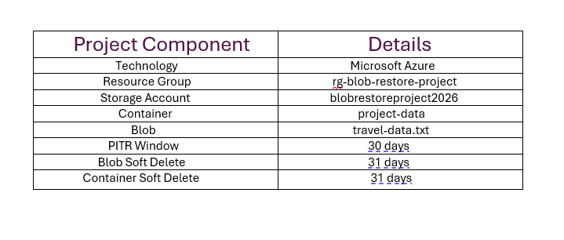
2. PROJECT OBJECTIVE
The main objective of the project is to implement a cloud-based data protection and recovery solution using Azure Blob Storage.
The project aims to:
- Protect blob data from accidental overwriting and modification.
- Maintain previous versions of blob data using Blob Versioning.
- Protect deleted blobs using Blob Soft Delete.
- Protect deleted containers using Container Soft Delete.
- Track blob changes using Change Feed.
- Configure Point-in-Time Restore with a 30-day recovery window.
- Manage older blob versions using Lifecycle Management.
- Simulate an accidental data overwrite.
- Recover the original data from a previously stored blob version.
- Demonstrate a practical cloud data recovery workflow.

- PROBLEM AND SOLUTION
Problem:
Data stored in cloud environments can be accidentally modified, overwritten, or deleted.
If previous versions are not maintained, the original information may be difficult to recover.
A data protection mechanism is therefore required to maintain historical versions and provide recovery options.

Solution:

The project uses Azure Blob Storage data protection features to maintain previous versions and protect against accidental deletion and modification.

Blob Versioning maintains previous versions of the blob. Blob Soft Delete and Container Soft Delete provide deletion protection. Change Feed records blob changes. Point-in-Time Restore is configured to provide a 30-day recovery window.

The recovery demonstration uses Blob Versioning to restore the original data after an accidental overwrite.

- AZURE SERVICES AND FEATURES

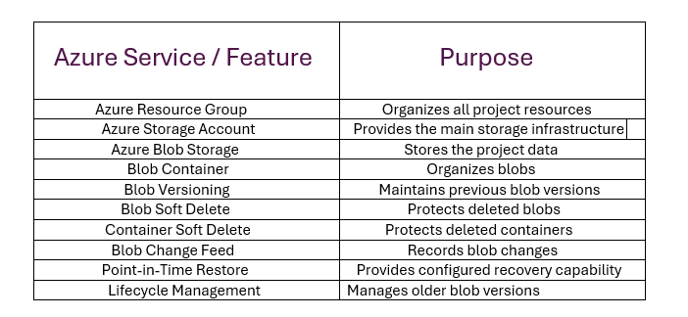

- PROJECT ARCHITECTURE

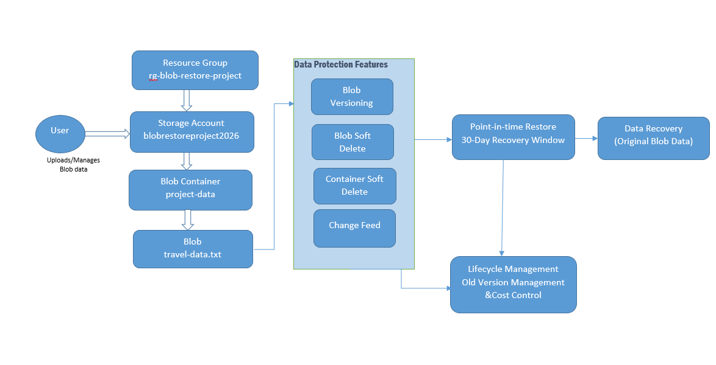

Figure 1: Architecture of Azure Blob Versioning and Point-in-Time Restore

- The user interacts with Azure through the Azure Portal.

- The project resources are organized inside the Resource Group named rg-blob-restore-project.

- The Resource Group contains the Storage Account blobrestoreproject2026.

- The Storage Account contains the project-data blob container, which stores the travel-data.txt file.

- Data protection features are configured at the storage level to protect the blob data. These include Blob Versioning, Blob Soft Delete, Container Soft Delete, and Change Feed.

- Point-in-Time Restore is configured with a 30-day recovery window.

- Lifecycle Management is used to manage older blob versions and control unnecessary storage consumption.

- The recovery process uses the stored blob versions to recover the original data after an accidental overwrite.

- PROJECT IMPLEMENTATION WORKFLOW

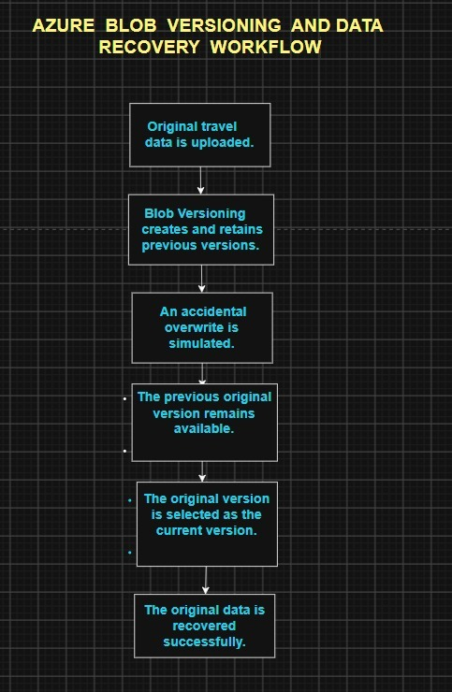

Figure 2: Azure Blob Versioning and Data Recovery Workflow

- The workflow shows how the project protects blob data using Blob Versioning and how the original data is recovered after an accidental overwrite.
- The original travel data is uploaded to Azure Blob Storage. Blob Versioning automatically retains previous versions when the blob is modified.
- An accidental overwrite is then simulated. Since the previous version is retained, the original version remains available.
- The original version is selected and made the current version. The blob is then verified to confirm that the original data has been successfully recovered.
- PROJECT IMPLEMENTATION

  - Create Resource Group
A Resource Group named rg-blob-restore-project was created in Microsoft Azure.
The Resource Group is used to organize and manage the resources required for the project.
Configuration:
• Resource Group: rg-blob-restore-project
• Region: East Asia
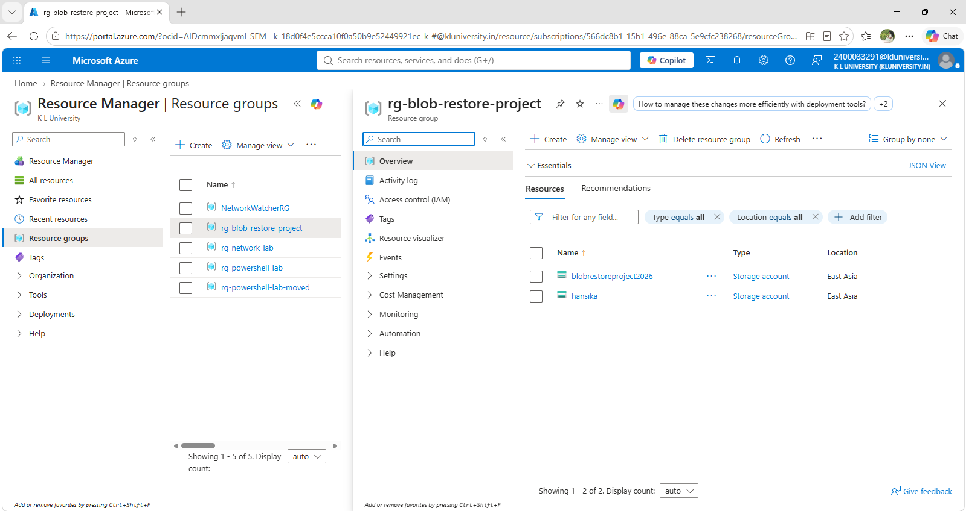
Figure 3: Azure Resource Group Created for the Project
  - Create Storage Account

An Azure Storage Account named blobrestoreproject2026 was created inside the project Resource Group.
The Storage Account provides the main storage infrastructure for the project.
Configuration:
• Storage Account: blobrestoreproject2026
• Region: East Asia
• Performance: Standard
• Redundancy: LRS
• Hierarchical Namespace: Disabled

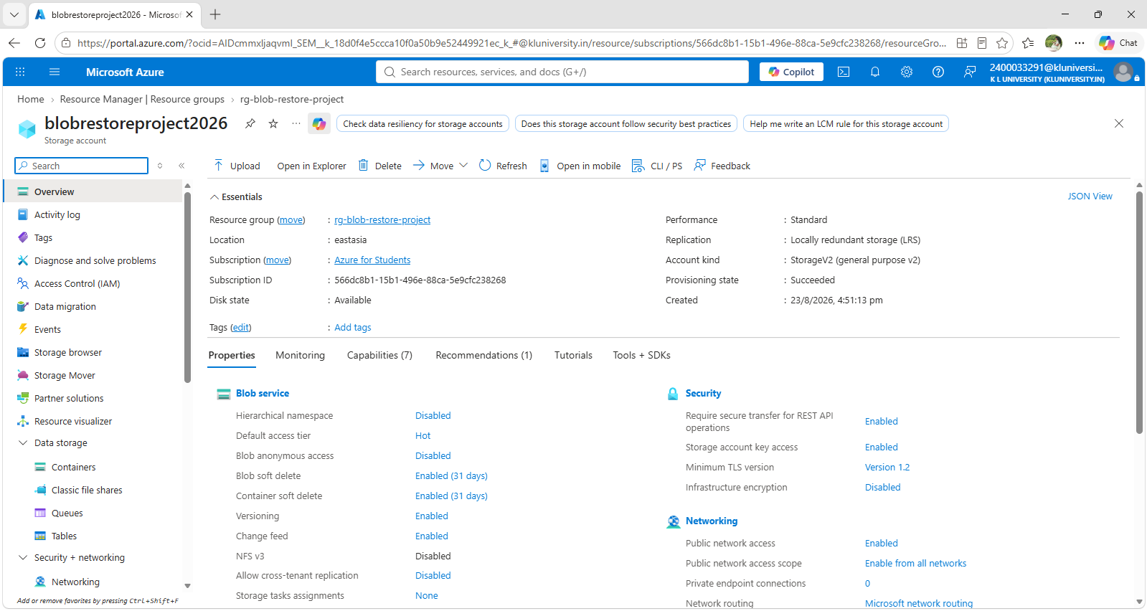
Figure 4: Azure Storage Account Configuration

  - Create Blob Container

- A private blob container named project-data was created inside the Storage Account.
- The container is used to organize and store the project blob data.

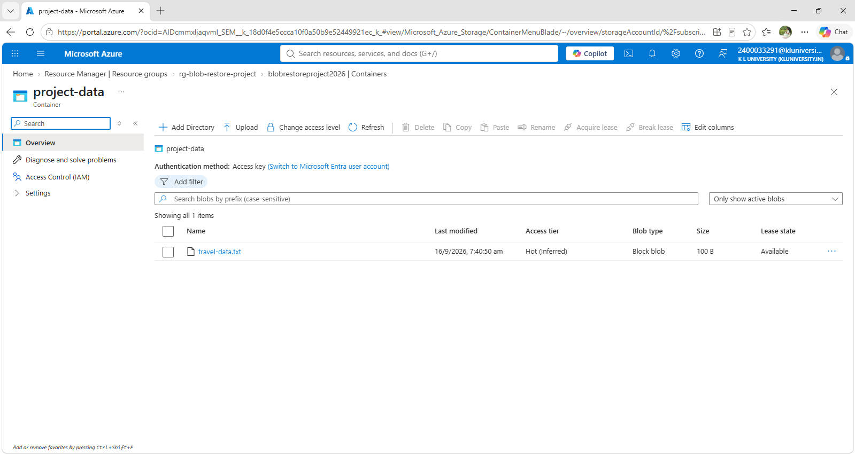
Figure 5: Project Blob Container

  - Upload the Project Blob

- A text file named travel-data.txt was uploaded into the project-data container.

- The file contains sample travel data and is used to demonstrate Blob Versioning and data recovery.

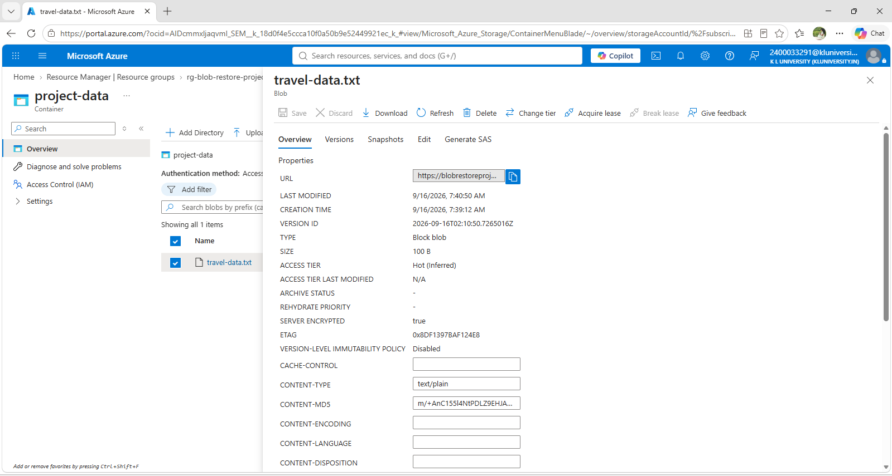
Figure 6: travel-data.txt Stored in Azure Blob Storage

  - Configure Blob Versioning

- Blob Versioning was enabled for the Storage Account.

- When the contents of travel-data.txt are modified, Azure automatically retains previous versions of the blob.

- This feature is used as the main recovery mechanism demonstrated in this project.

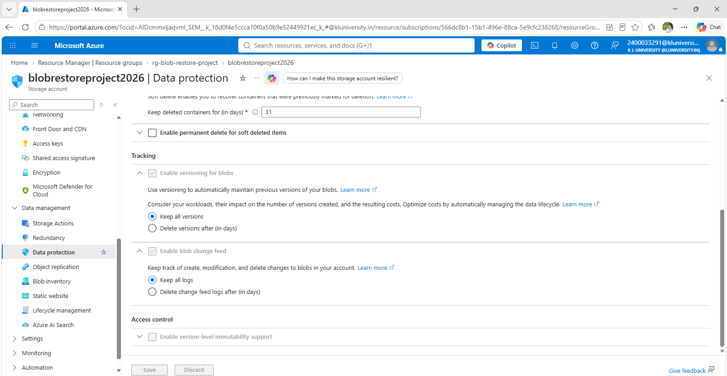
Figure 7: Blob Versioning Enabled

  - Configure Blob Soft Delete

- Blob Soft Delete was enabled with a retention period of 31 days.

- This feature protects individual blobs from accidental deletion and allows deleted blobs to be recovered during the retention period.

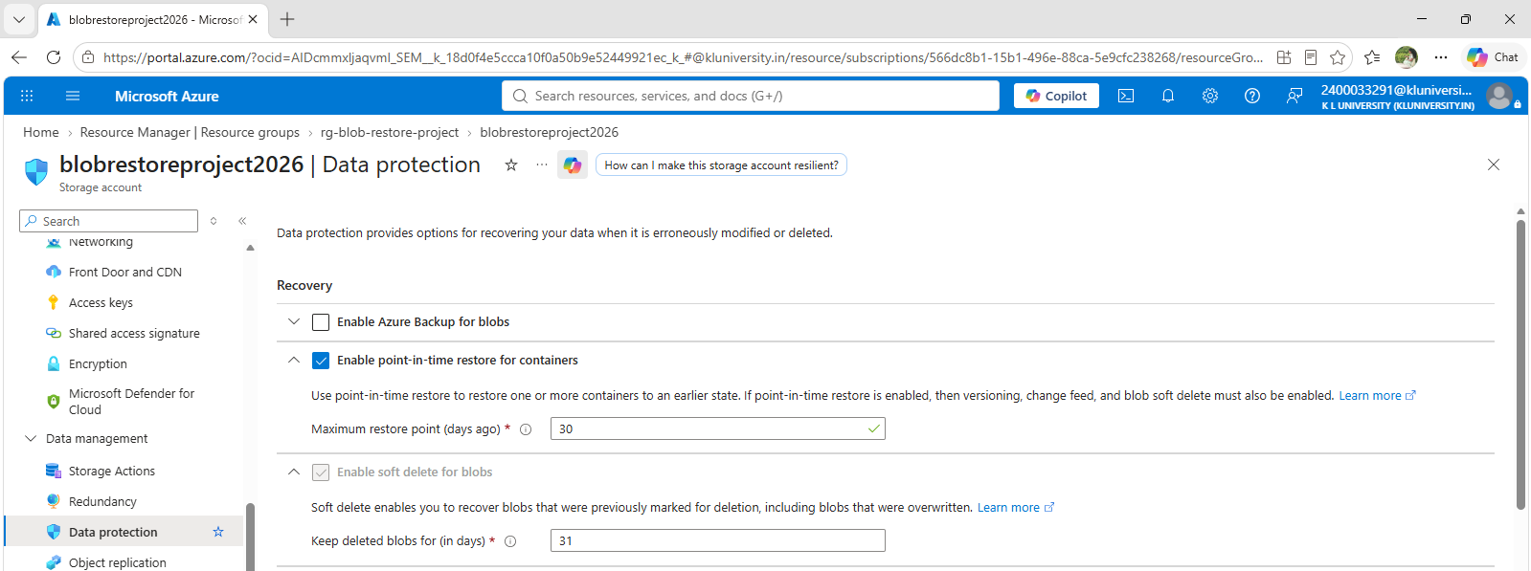
Figure 8: Blob Soft Delete Configuration

  - Configure Container Soft Delete

- Container Soft Delete was enabled with a retention period of 31 days.
- This feature provides protection against accidental deletion of the project-data container.

Figure 9: Container Soft Delete Configuration
  - Configure Change Feed
- Blob Change Feed was enabled for the Storage Account.
- Change Feed records changes made to blobs and provides a record of blob activity that can support monitoring, auditing, and recovery-related scenarios.

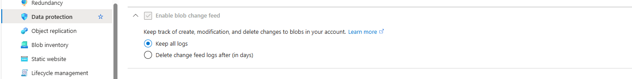
Figure 10: Blob Change Feed Enabled

  - Configure Point-in-Time Restore
- Point-in-Time Restore was configured with a 30-day recovery window.
- This feature provides the capability to restore supported blob data to an earlier point in time.
- In this project, Point-in-Time Restore was configured successfully. However, the actual hands-on recovery demonstration was performed using Blob Versioning by selecting a previous version and making it the current version.

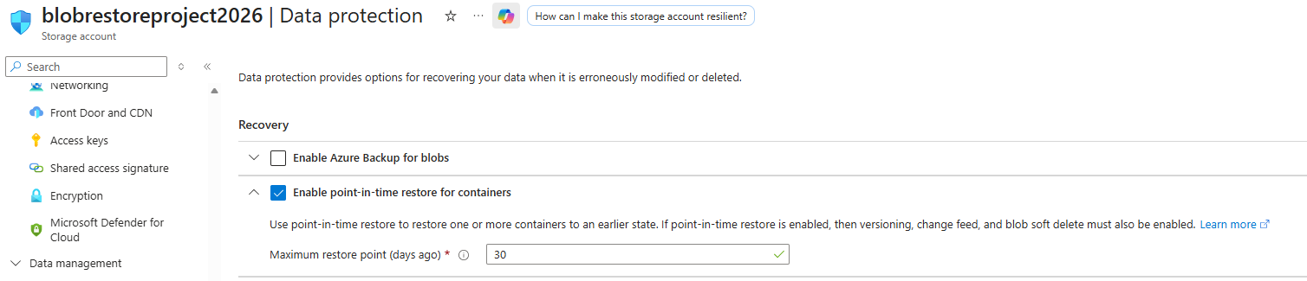
Figure 11: Point-in-Time Restore Configured with 30-Day Recovery Window
  - Configure Lifecycle Management

- A Lifecycle Management rule named manage-old-versions was configured.
- The rule is intended to manage older blob versions after the specified period and helps control unnecessary storage consumption.

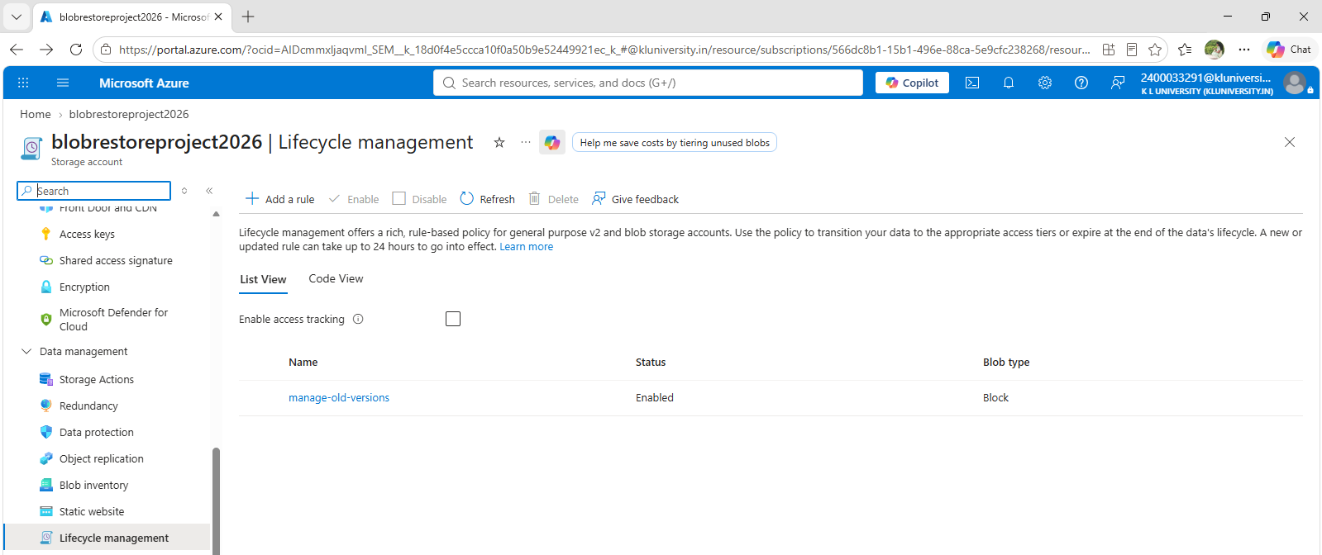
Figure 12: Lifecycle Management Rule
- BLOB VERSIONING TEST
After enabling Blob Versioning, the travel-data.txt file was modified to generate multiple blob versions.
The versions were verified from the Azure Portal.
The original version contained:
VoyageCraft Travel Data
Version: 1
Status: Original
Recovery Test: Initial Data

A later version contained:
VoyageCraft Travel Data
Version: 2
Status: Updated
Recovery Test: First Modification
The presence of multiple versions confirmed that Blob Versioning was working correctly.
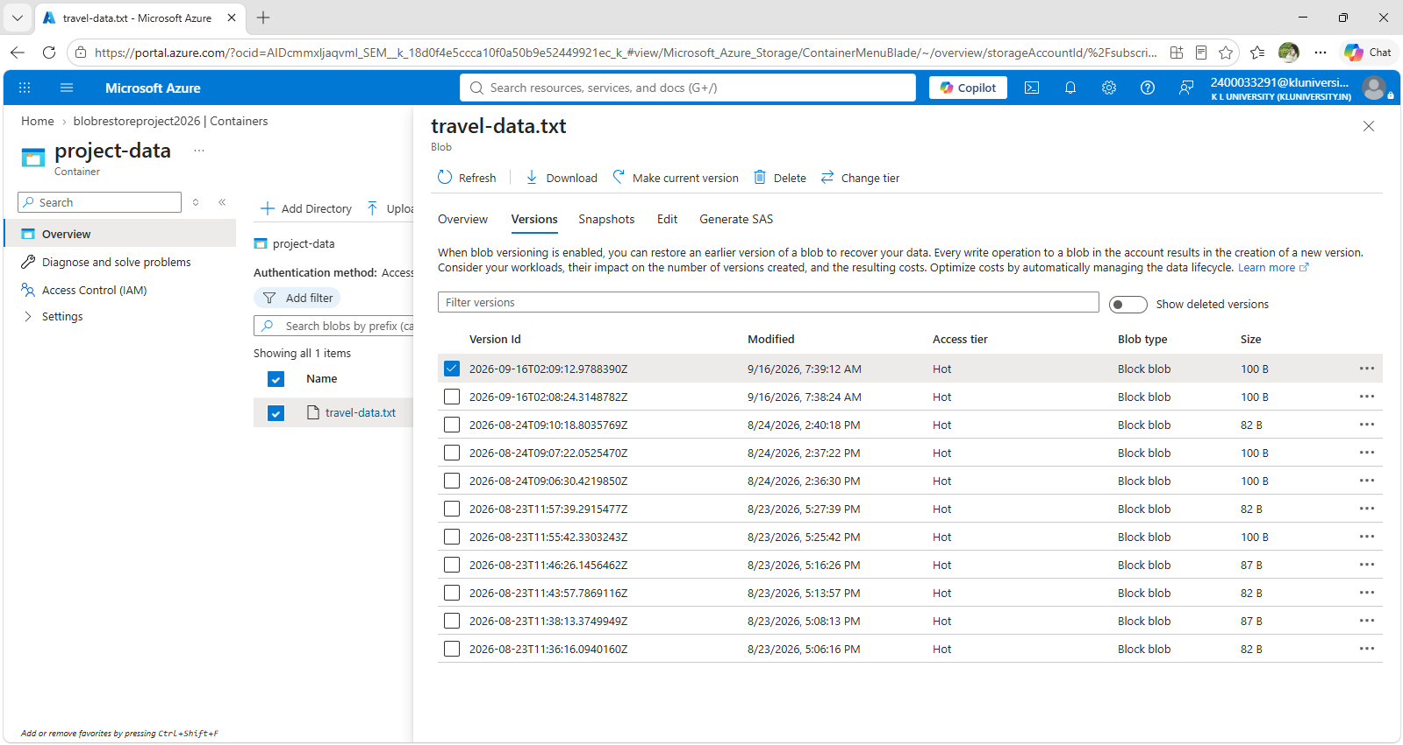
Figure 13: Multiple Versions of travel-data.txt
- ACCIDENTAL OVERWRITE SIMULATION
- To test the recovery capability, an accidental overwrite scenario was simulated.
- The contents of travel-data.txt were changed to represent corrupted or accidentally overwritten data.
- The simulated overwritten content was:
- Version: 4
- Status: ACCIDENTALLY OVERWRITTEN
- Recovery Test: CORRUPTED DATA
- This represents a situation where important cloud data is accidentally replaced by incorrect data.

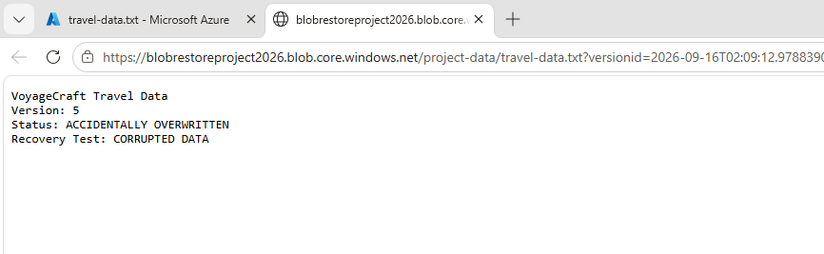
Figure 14: Simulated Accidental Blob Overwrite
10. DATA RECOVERY
- After the accidental overwrite, the available blob versions were examined.
- The previously stored original version containing the correct travel data was identified.
- The original version was selected and the Make current version option was used.
- This restored the selected previous version as the current blob version.
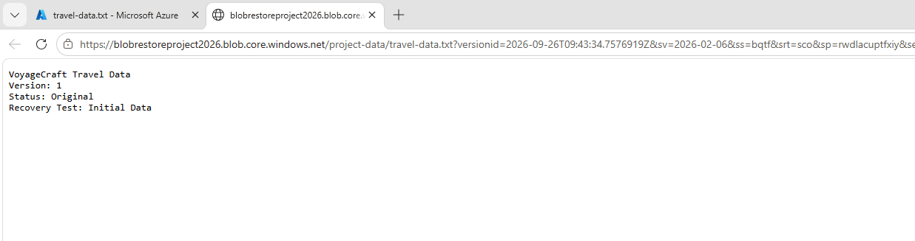
Figure 15: Selecting the Original Blob Version for Recovery
11. RECOVERY SUMMARY
The recovery test successfully demonstrated that a previous version of the blob could be used to recover the original data after an accidental overwrite.

12. PROJECT RESULT
- The Azure Blob Versioning and Point-in-Time Restore project was successfully implemented using Microsoft Azure.
- The Storage Account, Blob Container, and travel-data.txt blob were successfully created.
- Blob Versioning was enabled and multiple versions of the blob were generated during testing.
- Blob Soft Delete and Container Soft Delete were configured for deletion protection.
- Change Feed was enabled to record blob changes.
- Point-in-Time Restore was configured with a 30-day recovery window.
- Lifecycle Management was configured to manage older blob versions.
- An accidental overwrite was successfully simulated, and the original data was recovered using a previously stored blob version.
- The recovery verification confirmed that the original data was successfully restored.

